

TECHNICAL UNIVERSITY OF KENYA
FACULTY OF APPLIED SCIENCES AND TECHNOLOGY
SCHOOL OF COMPUTING & INFORMATION TECHNOLOGY
END OF SEMESTER MAY 2017 EXAMINATION SERIES
SECOND SEMESTER EXAMINATIONS 2016/2017
THIRD YEAR EXAMINATIONS FOR THE DEGREE OF
BACHELOR OF TECHNOLOGY IN COMMUNICATION AND COMPUTER NETWORKS
ECCE 3104: COMMUNICATION SYSTEMS 2

TIME: 2 Hours MAY 2017

Instructions to candidates:
This paper consists of FIVE Questions.
Answer Question ONE [30 Marks] and any other TWO Questions [20 Marks Each].
Write your college number on the answer sheet.
This paper consists of 6 printed pages
Candidates should check the question paper to ascertain that all the pages are printed as indicated and that no questions are missing.

© May 2017 The Technical University of Kenya Examinations

QUESTION ONE (30 MARKS) COMPULSORY
- State four benefits of a digital communication system (4 Marks)
- Explain the difference between:
  - PCM and PAM
  - Baseband signal vs bandpass signal
(4 Marks)
- Explain the term intersymbol interference (ISI) and describe how an equalizer can be used to counters the effect of ISI. Use diagrams for illustration. (3 Marks)
- Suppose the spectrum of a channel is between 5 MHz and 9 MHz, and SNR_{dB} = 24dB.
  - Calculate the capacity limit of the channel
  - Use Nyquist formula to calculate the required number of signaling levels to achieve the limit.
(2 Marks)
- Draw constellation diagrams for:
  - BPSK
  - 8-PSK
  - Binary ASK
  - 16 – QAM
(4 Marks)
- State four advantages of spread spectrum (2 Marks)
- Draw a time-frequency diagram showing the operation of FHSS (2 Marks)
- State one advantage and one disadvantage high order modulation schemes. (2 Marks)
- Assume that equally-likely return to zero pulses are coherently detected over a Gaussian channel with N_{o} = 10⁻⁸ Watt/Hz. Assume that synchronization is perfect, and that the received pulses have an amplitude of 100mV. If the bit error probability specification is P_{B} = 10⁻³, find the largest data rate that can be transmitted using the system. (4 Marks)
- There are three major types of speech coders. State the type of coders represented by A, B, and C in Fig 1(j). (3 Marks)

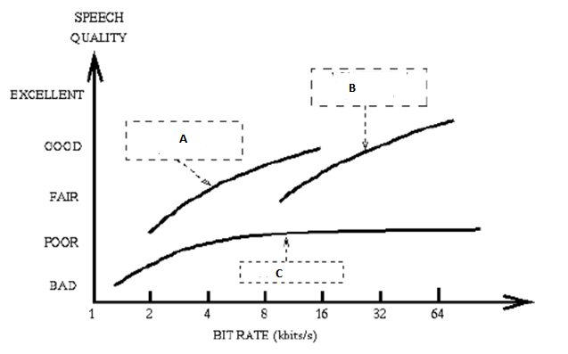
Figure 1(j)

QUESTION TWO (20 MARKS)
- Explain three sources of signal corruption during sampling, quantization and transmission. (3 Marks)
- The information in an analog waveform with maximum frequency f_{m}=3kHz is to be transmitted over an M-ary PAM system where the number of pulse levels is M=16. The quantization distortion is specified not to exceed ±1% of the peak to peak analog signal.
  - What is the maximum number of bits/sample or bits/PCM word that should be used in digitizing the analog waveform?
  - What is the minimum required sampling rate and what is the resulting transmission rate?
  - What is the PAM pulse or symbol transmission rate?
  - If the transmission bandwidth (including filtering) equals 12kHz, determine the bandwidth efficiency of the system?
(4 Marks)
- A voice signal (300 to 3300 Hz) is digitized such that quantization distortion is ≤ ±3% of the peak-to-peak signal voltage. Assume a sampling rate of 8000 samples/s and multi-level PAM waveform with M=32 levels. Find the theoretical minimum system bandwidth that avoids ISI. (4 Marks)
- A voice signal in the range of 300 to 3300 Hz is sampled at 8000 samples/s. We may transmit signals directly as PAM pulses or we may first convert each sample to a PCM format and use binary (PCM) waveforms for transmission.
  - What is the minimum bandwidth required for detection of PAM with no ISI and with a filter roll-off characteristic of r=1?
  - Using the same roll-off characteristic, what is the minimum bandwidth required for detection of binary (PCM) waveforms if the samples are quantized to eight levels.
  - Repeat part (b) using 128 quantization levels.
(4 Marks)
- Consider the table 2(e)
Table 2(e)
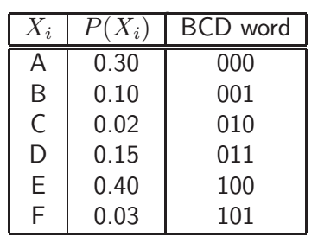
- A source emits symbols Xi, 1 ≤ i ≤ 6, in the BCD format with probabilities P(Xi) as given in Table 1, at a rate Rs = 9.6 kbaud (baud=symbol/second). State the information rate and the data rate of the source.
- Apply Huffman coding to the source signal characterised in Table 2(e). Are there any disadvantages in the resulting code words?
- What is the original symbol sequence of the Huffman coded signal 110011110000110101100?
- What is the data rate of the signal after Huffman coding? What compression factor has been achieved?
- Derive the coding efficiency of both the uncoded BCD signal as well as the Huffman coded signal.
(5 Marks)

QUESTION THREE (20 MARKS)
- Draw waveform to show the output modulated signal for the following modulation schemes:
  - 4-ASK
  - PSK
  - Q-PSK
  - FSK
(4 Marks)
- If bit rate for is 10 Mbps, calculate the baud/symbol rate and state the required bandwidth for:
  - BPSK
  - 16-PSK
  - 16-QAM
  - 8-FSK
(4 Marks)
- Find the number of expected bit errors made in one day by following continuously operating BPSK receiver. The data rate is 5000 bits/s. The input digital waveforms are s₁(t)=Acos_{o}t and s₂(t)=-Acos_{o}t where A=1 mV and the single sided noise power spectral density is N_{o} = 10⁻¹¹ W/Hz. Assume that signal power and energy per bit are normalized relative to 1 ohm resistive load.
(6 Marks)
- A bit error probability of P_{B} = 10⁻⁵ is for a system with data rate of 100kbits/s to be transmitted over an AWGN channel using coherently detected MPSK modulation. The system bandwidth is 50kHz. Assume that the system frequency transfer function is a raised cosine filter with a roll-off characteristic or r=1 and is used for symbol to bit assignment.
  - What E_{s}/N_{o} is required for the specified P_{B}?
  - What E_{b}/N_{o} is required?
For MPSK 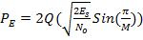

(6 Marks)

QUESTION FOUR (20 MARKS)
- Explain the difference between the following:
  - Waveform coders and vocoders
  - Linear predictive coder LPC and codebook excited LPC.
(4 Marks)
- Explain the difference between direct sequence spread spectrum and frequency hopping spread spectrum.
(2 Marks)
- State two wireless technologies that use:
  - Frequency hopping spread spectrum
  - Direct sequence spread spectrum
(2 Marks)
- Consider DS/BPSK spread-spectrum transmitter in the figure below. Let x(t) be the sequence 10011001, arriving at a rate of 75bits/s, where the left most bit is the earliest bit. Let g(t) be generated from shift register with an initial state of 1111 and a clock rate of 225 Hz.
  - Sketch the final transmitted sequence x(t)g(t)
  - What is the bandwidth of the transmitted (spread) signal)?
  - What is the processing gain?
(6 Marks)

- There are 11 equal-power terminals in CDMA communication system, transmitting signals toward a central node. Each terminal transmits information at 1kbits/s on a 100 kchips/s direct sequence spreading signal using BPSK.
  - If the receiver noise is negligible with respect to interference to from other users, what is the ration of bit energy to interference power spectral density (E_{b}/I_{o}) received by a receiving terminal?
  - What is the effect of E_{b}/I_{o} if all users double their output power?
  - If the users wish to expand their service to 101 equal power users, what must be done to the spreading codes to maintain original Eb/Io ratio?
(6 Marks)

QUESTION FIVE (20 MARKS)
- Explain the importance of FEC (2 Marks)
- The generator matrix of (7,3) linear block code is given as:
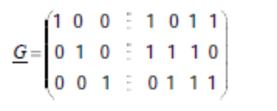
- List all possible codewords
- Find the minimum hamming distance for the code
- How many errors can be detected and corrected by the code
- Construct the standard array
- Given 0111101, determine whether this is a valid codeword. Correct it if it is not a valid codeword.
(9 Marks)
- Consider the table 5(c)
Table 5(c)
- A source emits symbols Xi, 1 ≤ i ≤ 6, in the BCD format with probabilities P(Xi) as given in Table 1, at a rate Rs = 9.6 kbaud (baud=symbol/second). State the information rate and the data rate of the source.
- Apply Shannon-Fano coding to the source signal characterised in Table 5(c). Are there any disadvantages in the resulting code words?
- What is the original symbol sequence of the Shannon-Fano coded signal 110011110000110101100?
- What is the data rate of the signal after Shannon-Fano coding? What compression factor has been achieved?
- Derive the coding efficiency of both the uncoded BCD signal as well as the Shannon-Fano coded signal.
(9 Marks)

